Sunrise Futures Financial Modeling Data Competition

Short Summary

University of Illinois at Urbana-Champaign

Yiwei Shen

Jiahao Zhu

Donghan Liu

Pengyu Chen

Ho Hin Jeremy Wong

1. First Glance of Data

Our goal is to optimize models to increase the prediction power of y_values. At the first glance of data, we observed that y_values are discrete. As shown in the picture, we aim to find the jump points of y_values, trying to explain why an y_value changes suddenly at a specific time point.

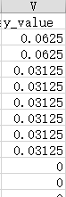

We believe that the status of the current time point depends only on the status of the time point 1 second before but not the past due to the nature of high frequency trading as we assumed. Therefore, we created 1 second time lag in our data set. We shifted the previous second trading price and size down to the current second, and then tried to predict y_value based on the data of the previous second.

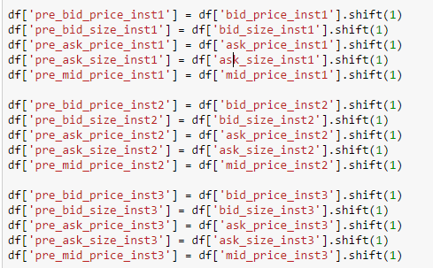

1. Relation Exploration

After obtaining our new shifted data set, we began to scatter plot relations between y_value and other independent variables.

1. Size:

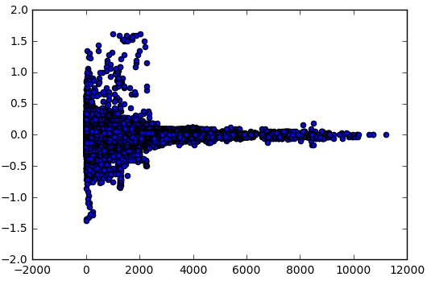

We observed that the y_value v.s. size plots have the same pattern for all three instruments. Small sized observations tend to have higher variances in y_values.

1. Price:

There are no obvious patterns in y_value v.s. prices for all three instruments.

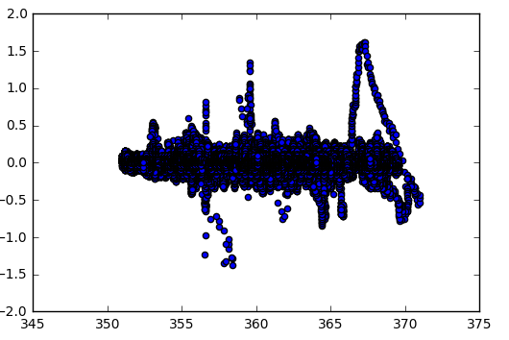

1. Net Trade

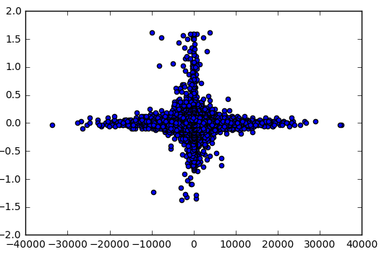

The plots of y_values v.s. net trade indicating a pattern that when net traded volumes are close to 0, the variances of y_values become larger. We inspired from these plots that the difference of trading sizes instead of sizes themselves are important to our models. Therefore, we created new columns representing price_diff and size_diff for three instruments.

1. Regression
2. Price

Since we are not sure whether there is any relationship between price and y_value, we tried to regress y_value on prices first.

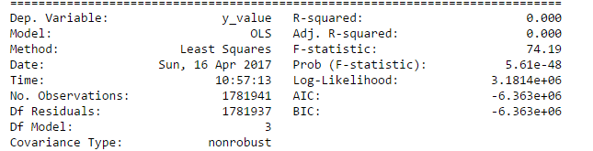

The result turns out that the price is not so much related to y_values.

1. Size

As we have discovered before, the size differences could be more useful than sizes themselves. Therefore, we tried to regress y_values on size differences.

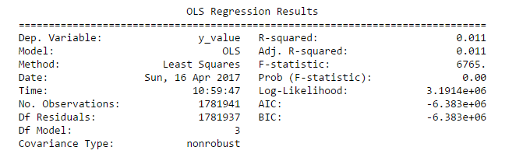

It turns out size differences does explain some of the behaviors of y_values.

Further, we tried to include interactions between size_diffs. It turns out that the R-square does not increase much. Therefore, simple model without intersection is more appropriate.

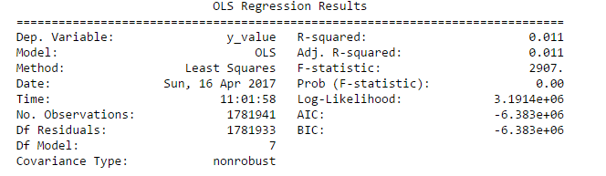

1. Size*Price

Now we consider the model include intersections between size_diff and price_diff

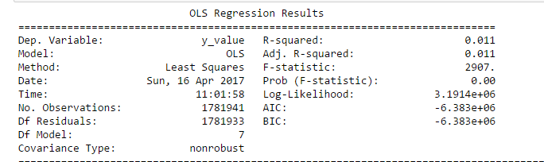

The model is not improved as well.

1. **Final Model**

In conclusion, we choose **y_value~ size_diff1 +size_diff2+size_diff3** as our final model due to consideration of R-square and concise of our model.